Part- 4 Chapter- 20
Aplia Homework: Exchange Rates and the Macroeconomy

1. Exchange rates and aggregate supply and demand
The following graph illustrates the aggregate demand and aggregate supply curves for the U.S. economy. Suppose that the U.S. dollar has recently depreciated relative to other foreign currencies.
Shift the appropriate curve or curves on the graph to illustrate how the depreciation in the U.S. dollar affects the U.S. economy.
Note: Select and drag one or both of the curves to the desired position. Curves will snap into position, so if you try to move a curve and it snaps back to its original position, just drag it a little farther.

According to your answer to the graph question, the depreciation of the U.S. dollar leads to __________ in the aggregate price level and __________ in aggregate output in the United States.

2. Policy effects in an open economy
The following graph shows various aggregate demand and aggregate supply curves for the United States. This question will analyze the effect of either fiscal or monetary policy on an economy with mobile capital and floating exchange rates.
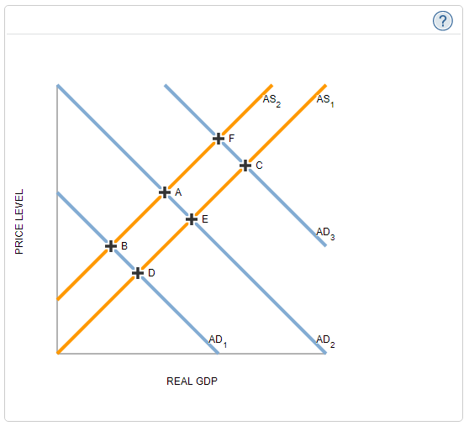

Suppose the government decides to cut taxes.
Fill in the following paragraph to indicate the effects of such a policy in an open economy.
Because this is __________ fiscal policy, aggregate demand will _________, which leads to a ________ in both real GDP and the price level. In a closed economy, this is the total effect of such a policy. However, in an open economy, it is necessary to consider effects of changes in interest rates and thus the exchange rate. Since this kind of fiscal policy _________ interest rates, American securities become __________ attractive to foreign investors. This currency _________, causing aggregate demand to _________ and aggregate supply to _________.

Given the information presented in the summary paragraph, determine which aggregate demand curves must be the initial AD curve, the new AD curve if the economy is closed, and the new AD curve if the economy is open. (Hint: The number labels on the graph are for identification only and do not imply any particular order of shifts.)
Fill in the following table with your results. Assume that each curve (AD1AD1, AD2AD2, and AD3AD3) should be selected only once.
AD Curves | AD1AD1 | AD2AD2 | AD3AD3
Original demand | ______ | ______ | ______
New demand, if the economy is closed | ______ | ______ | ______
New demand, if the economy is open | ______ | ______ | ______

Now complete the same analysis for the aggregate supply curve. Note here that each curve (AS1AS1 and AS2AS2) may be selected more than once.
AS Curves | AS2AS2 | AS1AS1
Original supply | ______ | ______
New supply if closed economy | ______ | ______
New supply if open economy | ______ | ______

In an open economy, this kind of fiscal policy moves the economy from point _____ to point _____.

3. Understanding the trade deficit through the fundamental equation
The equilibrium condition for GDP in an open economy is:
Y = C + I + G + (X – M)
GDP can be either ________________________, so it is necessary that:

Y = _____________.

Substituting the second equation into the first equation and rearranging yields:
X – M = _____________

The fundamental equation shows that an increase in the taxes will cause the budget deficit to __________, which should ________ the trade deficit.

4. Causes of the U.S. trade deficit
Which of the following contributed to the rising U.S. trade deficit between 1997 and 2005? Check all that apply.

Falling world prices for U.S. exports
A large decrease in the U.S. saving rate combined with an unchanged U.S. investment rate
Weak economic growth in the United States compared with the rest of the world

Which of the following statements support the view that the trade deficit is a problem? Check all that apply.

The United States will need to undergo significant economic adjustments as the government begins to pay off foreign investors' claims on American assets.
The United States will be able to pay off future obligations without major problems, as it will create more wealth with the investment from foreign countries.
A current account deficit is the result of a capital account surplus.
Americans save too little while consuming too much.

5. Changing the trade balance
Suppose the fictional country of Nevicia is under pressure from its trading partners to decrease its trade surplus.
Which of the following would help decrease Nevicia's trade surplus? Check all that apply.

Increasing taxation while holding government expenditure, saving, and investment constant
Encouraging the economy of Nevicia to grow more quickly than the economies of Nevicia's trading partners

True or False: If the government of Nevicia lowers its trade surplus by repealing tariffs, Nevicia can expect, in addition to an increase in imports, changes in either the government deficit, the gap between saving and investment, or both.
True
False

